Project Design Phase-II
Data Flow Diagram & User Stories

Date | 09 February 2026
Team ID | LTVIP2026TMIDS80676
Project Name | FreelanceFinder: Discovering Opportunities, Unlocking Potential
Maximum Marks | 4 Marks

Data Flow Diagrams:
A Data Flow Diagram (DFD) is a traditional visual representation of the information flows within a system. A neat and clear DFD can depict the right amount of the system requirement graphically. It shows how data enters and leaves the system, what changes the information, and where data is stored.

DFD Level-1
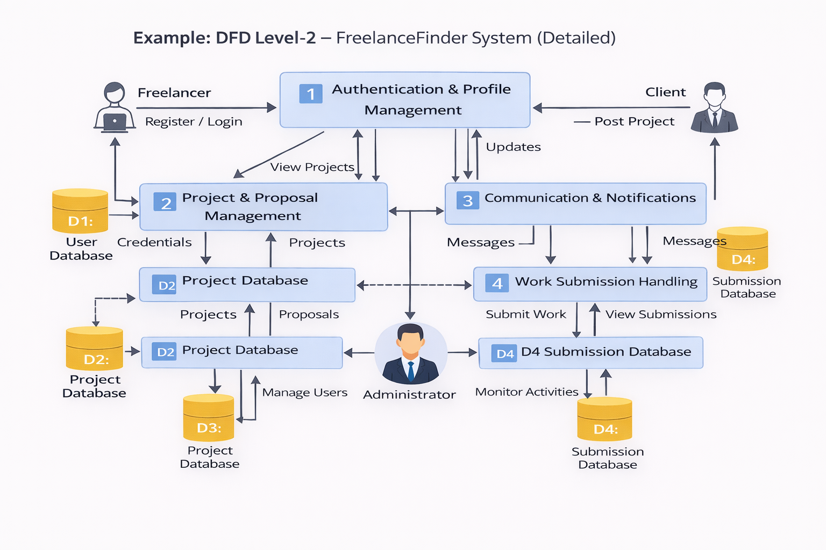
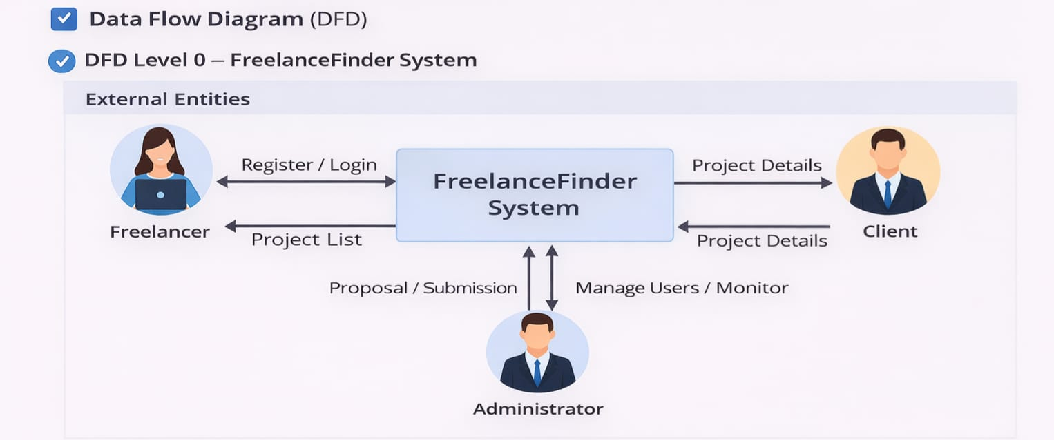

Stories

User Type | Epic | USN | User Story | Acceptance Criteria | Priority | Release
Freelancer | Registration | USN-1 | As a freelancer, I create an account | Dashboard opens after signup | High | Sprint-1
Freelancer | Login | USN-2 | I log in securely | JWT authentication works | High | Sprint-1
Freelancer | Profile | USN-3 | I update skills & profile | Data saved successfully | Medium | Sprint-1
Freelancer | Browse Projects | USN-4 | I view project listings | Projects displayed | High | Sprint-1
Freelancer | Apply Project | USN-5 | I send proposal | Client receives proposal | High | Sprint-2
Freelancer | Submission | USN-6 | I upload completed work | File visible to client | High | Sprint-2
Client | Project Posting | USN-7 | I create projects | Project stored in DB | High | Sprint-1
Client | Proposal Review | USN-8 | I accept/reject proposals | Status updated | High | Sprint-2
Client | Communication | USN-9 | I chat with freelancer | Messages visible | Medium | Sprint-2
Client | View Work | USN-10 | I see submissions | File preview works | High | Sprint-2
Admin | User Management | USN-11 | I manage users | Roles updated | Medium | Sprint-3
Admin | Monitoring | USN-12 | I view system activity | Dashboard loads data | Medium | Sprint-3
Admin | Security | USN-13 | I control access | Unauthorized blocked | Medium | Sprint-3

